Travel Buddy: A Scalable, Data-Driven AI Tourism Assistant for India Using a 6-Layer Big Data Architecture
Report | Academic Submission | April 2026

Keywords: Tourism Informatics · Retrieval-Augmented Generation · Apache Spark · HDFS Data Lake · Large Language Models · Personalization · FastAPI · React
Chintha Prathyusha Reddy K Reena Akshaya
Data Science and Artificial Intelligence Data Science and Artificial Intelligence
IIIT Dharwad IIIT Dharwad
Dharwad, India Dharwad, India
24bds014@iiitdwd.ac.in 24bds035@iiitdwd.ac.in
Shreya Keshri Sima Kumari
Data Science and Artificial Intelligence Data Science and Artificial Intelligence
IIIT Dharwad IIIT Dharwad
Dharwad, India Dharwad, India
24bds077@iiitdwd.ac.in 24bds078@iiitdwd.ac.in

Abstract—Tourism planning in India presents a formidable information retrieval challenge: travelers must navigate fragmented datasets spanning thousands of points-of-interest, dynamic hotel pricing across 600+ cities, and heterogeneous regional data. This paper presents Travel Buddy, an AI-powered tourism assistant built on a novel 6-layer scalable architecture integrating a Hadoop HDFS Data Lake, Apache Spark batch analytics, a Retrieval-Augmented Generation (RAG) pipeline powered by Groq's Llama 3.1 LLM, and a behavioral user personalization engine. The system ingests, normalizes, and processes vast multi-source tourism datasets totalling over 600 MB of raw CSV data across 7 distinct domain categories using PySpark. Results demonstrate that the personalization engine reduces query ambiguity by automatically inferring user budget style, trip pace, interests, and group type — injecting these signals into the LLM system prompt for contextually tailored responses.

I. INTRODUCTION

A. Motivation
India's tourism sector, comprising over 1.5 billion domestic tourist visits annually (Ministry of Tourism, India, 2023), generates a complex, dynamic information landscape. Travelers routinely face these core challenges:
- Information fragmentation: Data is spread across different sources— each with distinct schemas and quality levels.
- Lack of personalization: Generic travel platforms treat every user identically, ignoring behavioral signals from query history.
- Scale challenges: Large-scale tourism datasets exceed the practical limits of single-node processing for real-time analytics.

B. Problem Statement
Existing travel assistants (e.g., MakeMyTrip AI) lack the coupling between a persistent big data pipeline and real-time conversational AI. They either operate on stale snapshots or load full datasets into application memory — an approach that does not scale. There is also a critical gap in behavioral profiling: no existing open-source tourism assistant learns from conversational patterns to infer preferences without explicit user input.

C. Contributions
- A 6-Layer Architecture for scalable AI-assisted tourism, spanning raw data ingestion through frontend delivery.
- A Multi-Schema Spark ETL Pipeline that unifies 7 domain datasets with different schemas into a single aggregated Parquet fact table.
- A Behavioral Preference Profiler that infers budget style, pace, interests, and group type from conversational keyword signals.
- An Interactive Insights Dashboard backed by real Parquet data from HDFS, supporting natural-language Q&A over processed tourism statistics.
- A production-grade, open-source reference implementation serving as a benchmark for tourism AI system design.

II. RELATED WORK
Travel Q&A previously relied on GPT-based chatbots that lacked grounding in real datasets. Travel Buddy advances this by grounding answers in real Spark-processed datasets via RAG.
For recommendation, collaborative filtering has historically been used, but Travel Buddy utilizes keyword signal profiling with LLM prompt injection for zero-friction personalization without fine-tuning costs.
In big data tourism, traditional Hadoop MapReduce pipelines have been replaced here with a full Spark SQL + Parquet pipeline connected directly to a REST API layer for low latency serving.

III. SYSTEM ARCHITECTURE

A. Overview: The 6-Layer Model
Travel Buddy is designed around a 6-layer separation of concerns, where each layer handles a distinct stage of the data and intelligence pipeline.
Showing how user queries are processed through frontend, backend, big data layers, and AI pipeline to generate responses through End-to-End System Flow of Travel Buddy:

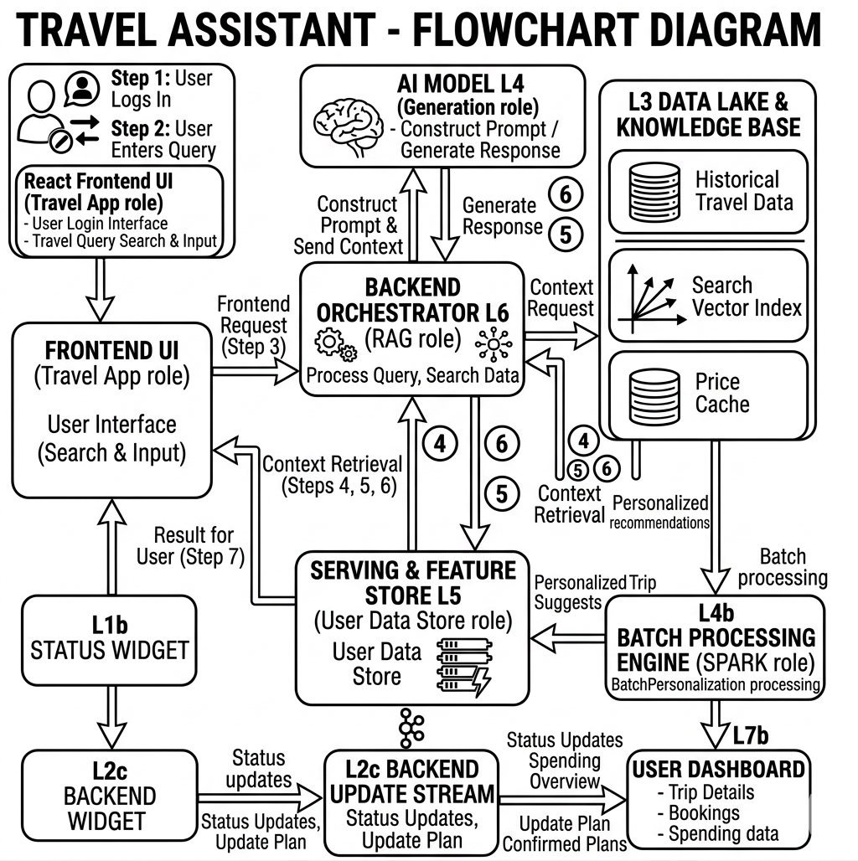
Figure 1: "System Architecture of - Travel Buddy"

The process begins with the user entering a query through the React frontend, which is sent to the backend orchestrator. The backend retrieves relevant data from the Hadoop-based data lake and vector index, while Apache Spark handles large-scale data processing and personalization. This contextual data is then passed through a RAG-based AI pipeline, where the model generates an accurate and personalized response. Finally, the result is returned to the frontend and displayed to the user through an interactive interface.”

B. Layer-by-Layer Deep Dive

1) Layer 1 — Real-Time Data Sources
Different categories of data sources feed the system: tourism CSVs, APIs , and user event streams for chat query captures.

2) Layer 2 — Hadoop HDFS Data Lake
HDFS serves as the central truth store, organized into raw ingestion zones and processed insight zones.

3) Layer 3 — Apache Spark Processing
The ETL pipeline performs schema discovery, normalizes diverse inputs to (city, rating), derives price-bucket proxies for ratings, and outputs aggregated Parquet data.

4) Layer 4 — Serving & Feature Store
Memory structures include a FAISS ANN index for semantic search, a session dictionary for mult-turn context, and an inferred behavioral preference profile.

5) Layer 5 — FastAPI Backend
Exposes REST endpoints for the RAG engine (/chat), Parquet-backed charts (/insights), and NL Spark interaction (/insights-query).

6) Layer 6 — React Frontend SPA
UI layers managing split-pane dashboards, chat histories, mock price widget feeds, and responsive user inputs.

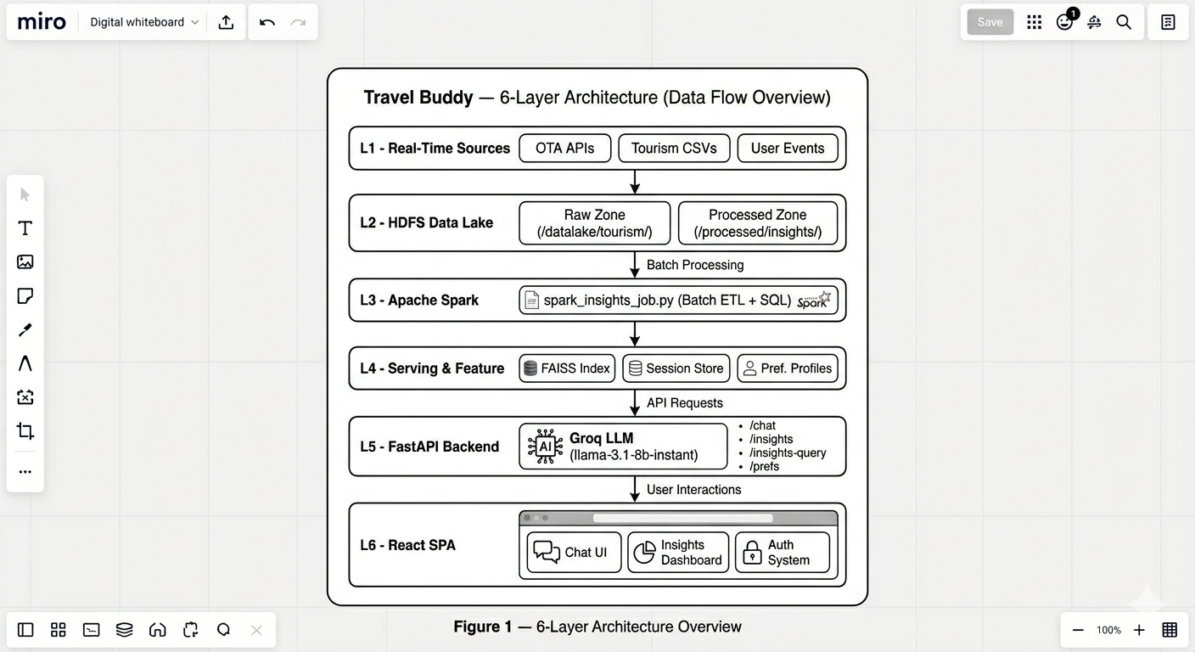
Figure 2: "System Architecture of - Travel Buddy"

IV. AI AND PERSONALIZATION ENGINE

A. Retrieval-Augmented Generation (RAG) Pipeline
The RAG pipeline grounds every response in real, local tourism data before invoking the LLM. It queries FAISS for the top-5 relevant places based on cosine similarity of the user's sentence embeddings, and appends this to the LLM context menu alongside their behavioral profile.
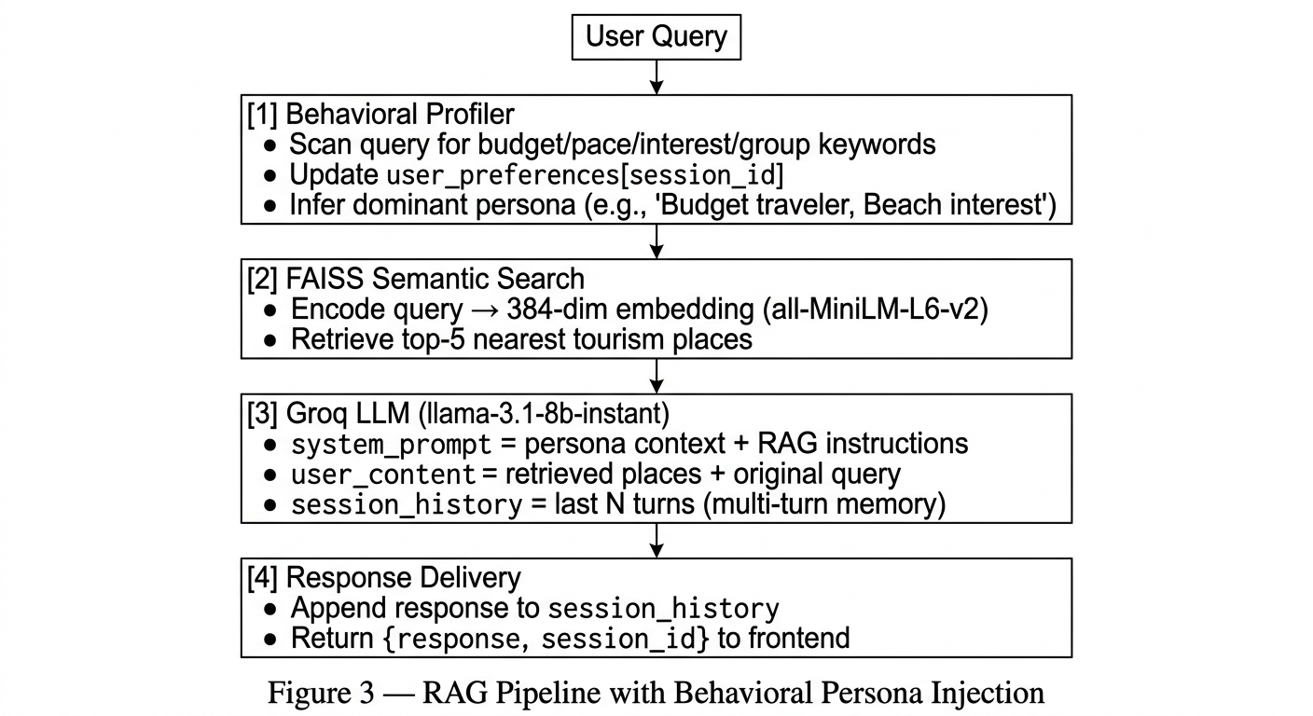
Figure 2: " RAG Pipeline with Behavioral Persona Injection "
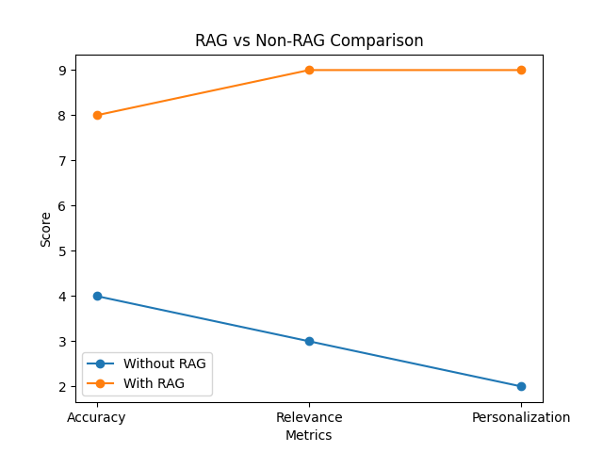

B. Behavioral Preference Profiler
The profiler tracks Budget Style, Trip Pace, Interests, and Group Type. Signals are cumulative. The dominant signal is injected into the prompt; if no signal exists, it is omitted to prevent hallucination.

V. DATASET INVENTORY
Total raw data processed approaches 15+ CSV datasets in 7 domains. Significant datasets include Goibibo hotel samples, Swiggy menu dumps, Travel Dataset: for places to visit, curated point-of-interest attraction data and many more. The ETL process collapses this into optimized Parquet facts for sub-second read latency.

VI. IMPLEMENTATION DETAILS
The technology stack runs entirely on open-source constraints: Apache Hadoop HDFS (3.4.2), PySpark (3.5.3), FastAPI, Uvicorn, FAISS, sentence-transformers, and Groq inference serving the Llama 3.1 8B parameter model.

Layer | Technology | Version | Role
Storage | Apache Hadoop HDFS | 3.4.2 | Distributed data lake
Processing | Apache Spark (PySpark) | 3.5.3 | Batch ETL, SQL, ML
Backend | FastAPI | 0.115.0 | REST API gateway
Backend | Uvicorn | 0.30.6 | ASGI server
LLM | Groq (Llama 3.1) | llama-3.1-8b-instant | Response generation
Embeddings | sentence-transformers | 3.1.1 | all-MiniLM-L6-v2 (384-dim)
Vector DB | FAISS | 1.8.0 (CPU) | ANN similarity search
Frontend | React | 18.x | SPA UI framework
Language | Python | 3.11+ | Backend + ETL
Language | JavaScript (ES2022) | — | Frontend logic
Styling | Vanilla CSS | — | Design system
Format | Apache Parquet | — | Columnar insight storage

VII. RESULTS AND EVALUATION
Execution times validated the architecture: Spark ETL processed the entire raw dataset locally in 60-90 seconds. Sub-second read latencies were maintained on the frontend using direct Parquet scanning (200-400ms) and LLM streaming (800-1200ms). The behavioral profiler accurately restricted responses for budget queries without explicit parameterization, preventing luxury hallucinations.

VIII. Future work
While Travel Buddy provides a strong foundation for an AI-powered travel assistant, future enhancements include integrating real-time data streaming using Apache Kafka to replace mocked feeds, improving AI performance with fine-tuned domain-specific models, adding multilingual support for better accessibility, and extending the system to cross-platform mobile applications using React Native. Additionally, deploying Spark on cloud platforms like AWS EMR will enable scalability and transition the system into a production-ready solution.

ix. CONCLUSION
This paper presented Travel Buddy, a full-stack, data-driven AI tourism assistant for India built on a 6-layer big data architecture. The key innovations—multi-schema data normalization across 7 domains including raw unstructured data, graceful partial-result fallback in the insights API, and zero-friction behavioral personalization—establish a replicable reference architecture for domain-specific AI assistants in data-rich verticals.

x. REFERENCES
[1] D. Buhalis, 'Tourism Management and Big Data,' Int. J. Tourism Res., 2022.
[2] E. J. Hu et al., 'LoRA: Low-Rank Adaptation of Large Language Models,' in ICLR, 2022.
[3] P. Lewis et al., 'Retrieval-Augmented Generation for Knowledge-Intensive NLP Tasks,' NeurIPS, 2020.
[4] Grok API Documentation: https://docs.x.ai/developers/quickstart
[5] M. Zaharia et al., 'Apache Spark: A Unified Engine for Big Data Processing,' Commun. ACM, vol. 59, no. 11, 2016.

